
SYMBIOSIS INSTITUTE OF TECHNOLOGY, PUNE
Symbiosis International (Deemed University)
(Established under section 3 of the UGC Act, 1956)
Re-accredited by NAAC with ‘A’ grade (3.58/4) | Awarded Category – I by UGC
Founder: Prof. Dr. S. B. Mujumdar, M. Sc., Ph. D. (Awarded Padma Bhushan and Padma Shri by President of India)

Assignment No. 15

Subject: | DevOps Lab
TCODE: | TE7950
Name of Student | Yash Patel
PRN No. | 23070122235
Branch | CSE, Batch (2023-27), L4
Academic Year &  Semester | 25 – 26, Sem VII
Date of Performance | 23rd July, 2026
Title of Assignment: | Basic Infrastructure as Code (IaC) with Terraform
Theory: | Infrastructure as Code (IaC) is the practice of managing and provisioning infrastructure using configuration files instead of manual processes. Terraform is an open-source IaC tool developed by HashiCorp that enables users to define, provision, modify, and destroy infrastructure resources in a consistent and automated manner. In this experiment, Terraform was used with the Local provider to create, update, and destroy a local text file. The commands terraform init, terraform plan, terraform apply, and terraform destroy demonstrated Terraform's workflow of initializing the working directory, previewing infrastructure changes, applying the desired configuration, and safely removing managed resources. This approach ensures repeatable deployments, version control of infrastructure, and simplified infrastructure management.  Commands Used  - terraform --version – Checks whether Terraform is installed correctly and displays the installed version.  - mkdir my-terraform-iac – Creates a new directory for storing the Terraform project files.  - cd my-terraform-iac – Navigates to the Terraform project directory.  - terraform init – Initializes the Terraform working directory by downloading the required providers and preparing the project.  - terraform plan – Generates an execution plan to preview the infrastructure changes before applying them.  - terraform apply – Applies the Terraform configuration and creates or updates the resources defined in the configuration file.  - terraform destroy – Removes all resources managed by the current Terraform configuration.
Implementation: | Step 1: Install Terraform  Installed Terraform — Successfully installed Terraform on the Windows system and verified the installation using the terraform --version command.  Step 2: Create the Project Directory  Created Terraform Project Directory — Created a new project directory named my-terraform-iac and navigated into it to store the Terraform configuration files.  Step 3: Create the Terraform Configuration File (main.tf)  Created Terraform Configuration File — Created the main.tf configuration file and defined the local provider along with a local_file resource to create a text file using Terraform.  Step 4: Initialize Terraform  Initialized Terraform — Initialized the Terraform working directory using the terraform init command, which downloaded the required provider plugins and prepared the project for execution.  Step 5: Plan the Changes  Generated Terraform Execution Plan — Generated an execution plan using the terraform plan command to preview the changes Terraform would make. The plan indicated that one new resource (local_file.my_example_file) would be created with no modifications or deletions.  Step 6: Apply the Changes  Applied Terraform Configuration — Applied the Terraform configuration using the terraform apply command, which successfully created the example.txt file as defined in the main.tf configuration. The generated file was verified in the project directory.  Step 7: Modify the Content and Re-apply  Command: terraform plan  Generated Updated Execution Plan — Modified the main.tf configuration and generated an updated execution plan using the terraform plan command. Terraform detected that the existing local_file resource would be replaced to apply the updated content.  Command: terraform apply  Applied Updated Terraform Configuration — Applied the modified Terraform configuration using the terraform apply command. Terraform successfully recreated the local_file resource with the updated content.  Verified Updated File Content — Verified that the example.txt file was successfully updated with the new content after applying the modified Terraform configuration.  Step 8: Destroy the Resource  Command: terraform destroy  Destroyed Terraform Resource — Executed the terraform destroy command, confirmed the destruction by entering yes, and successfully removed the Terraform-managed local_file resource from the local system.  Verified Resource Deletion — Verified that the example.txt file was successfully removed from the project directory after the Terraform-managed resource was destroyed.  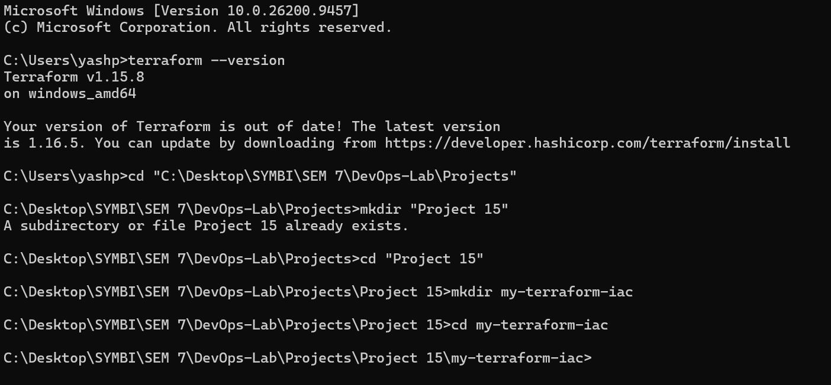  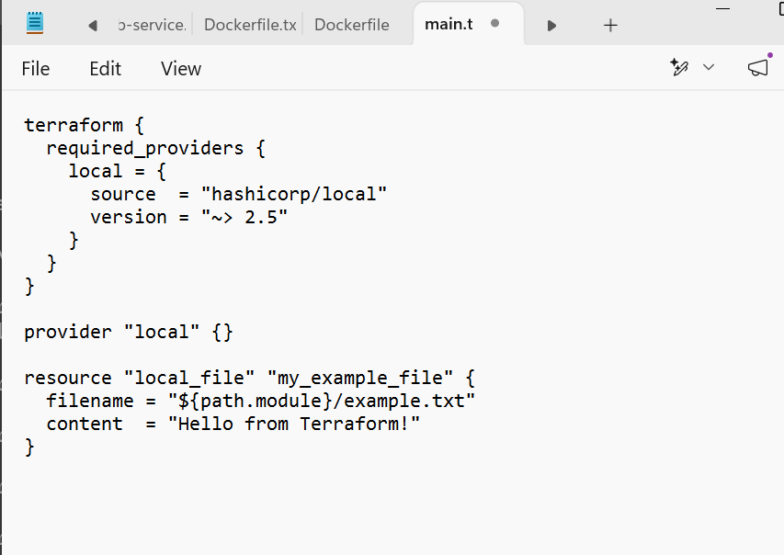  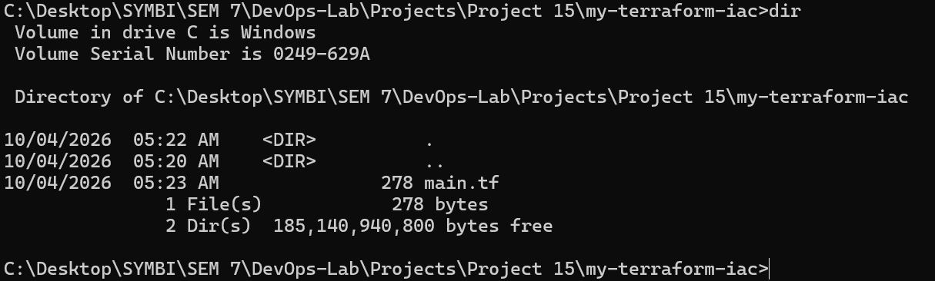  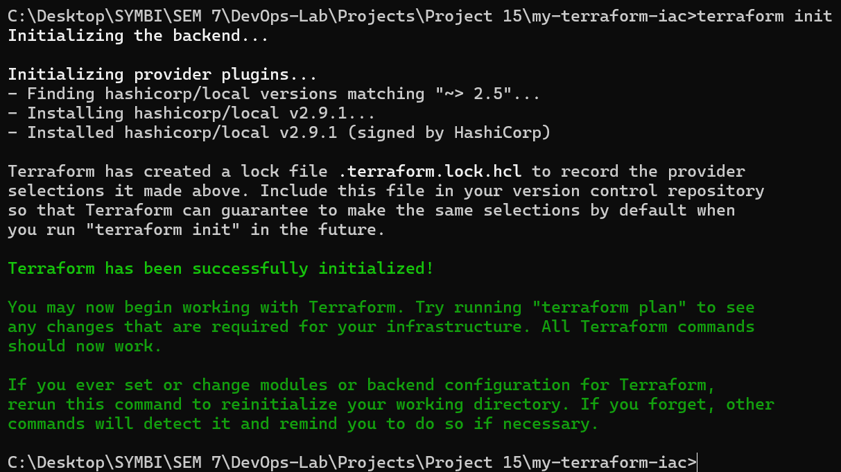  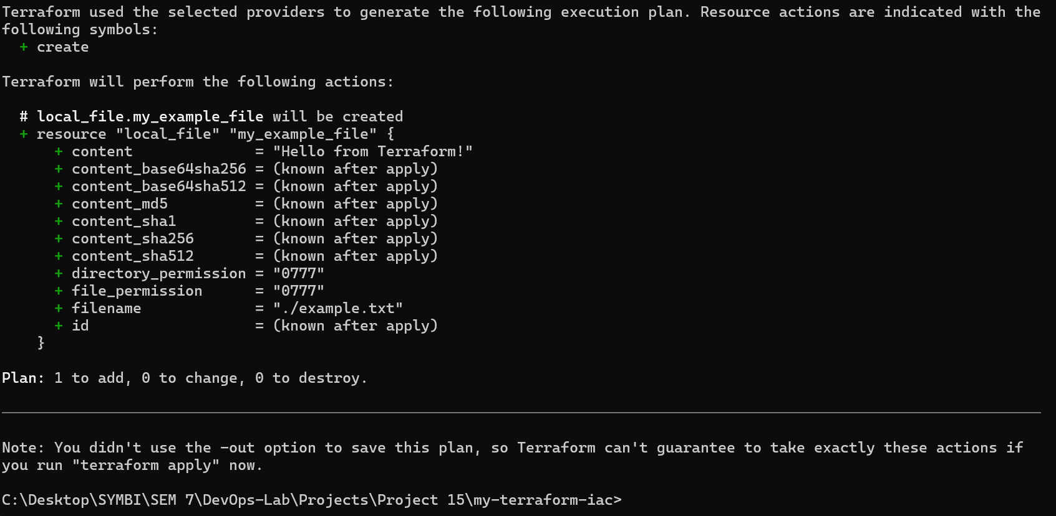  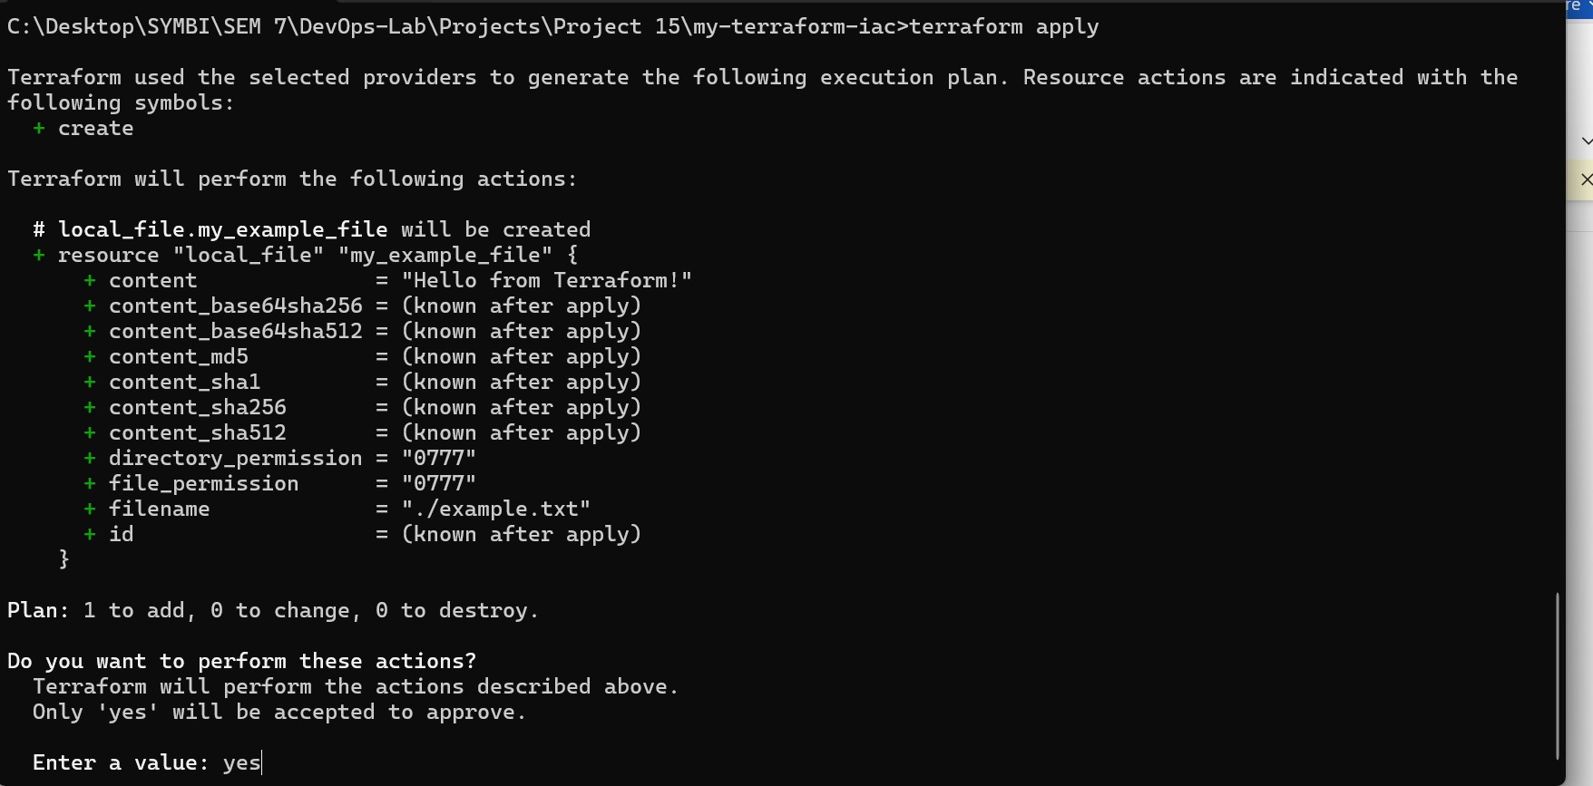  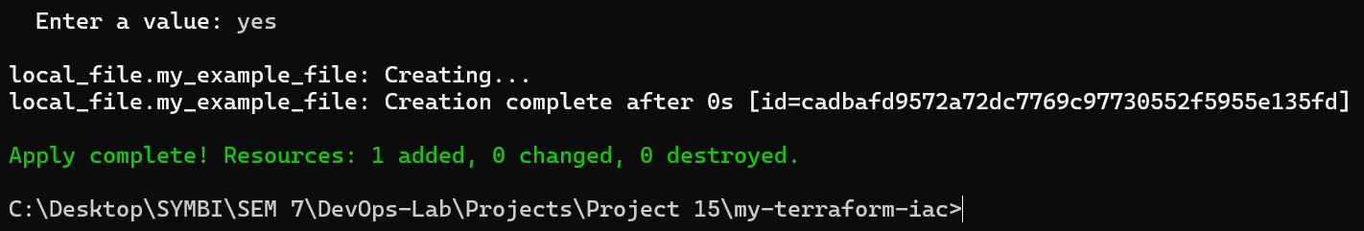  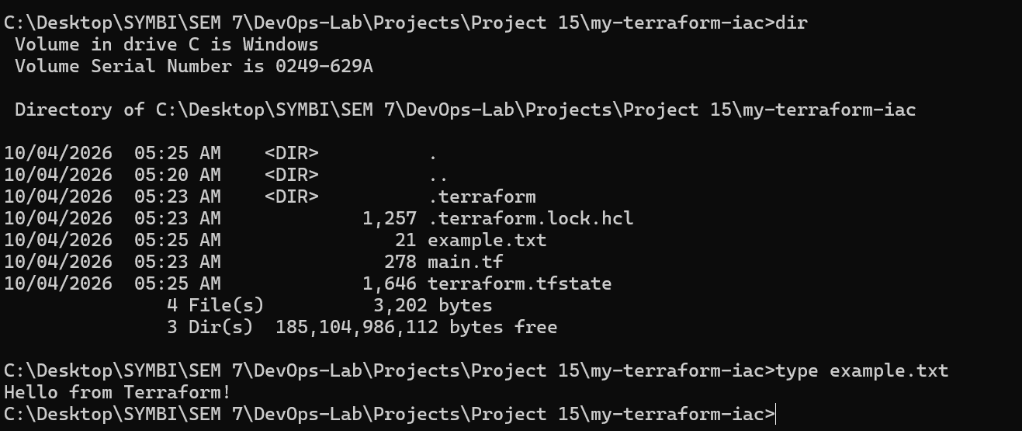  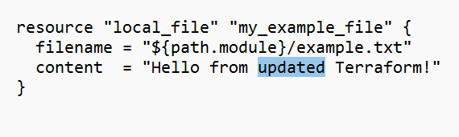  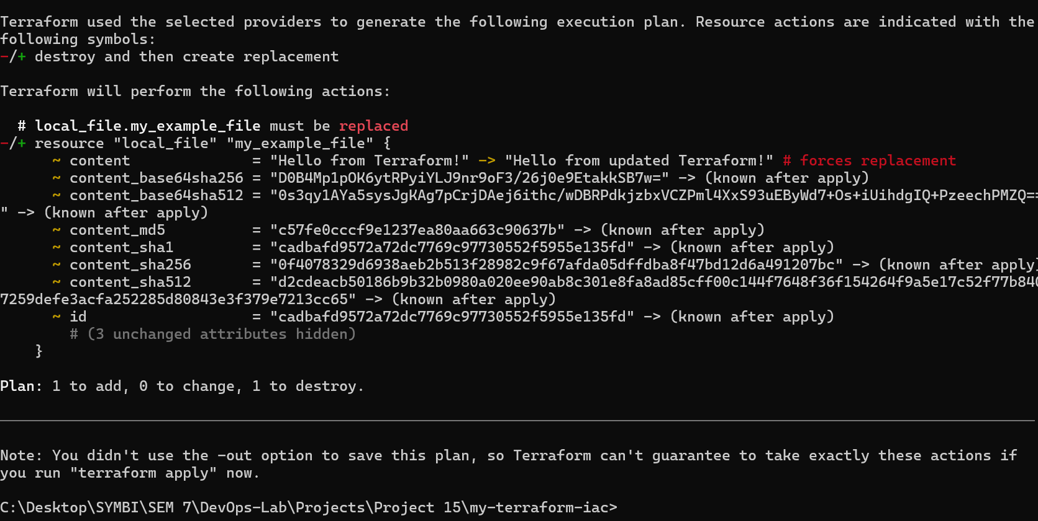  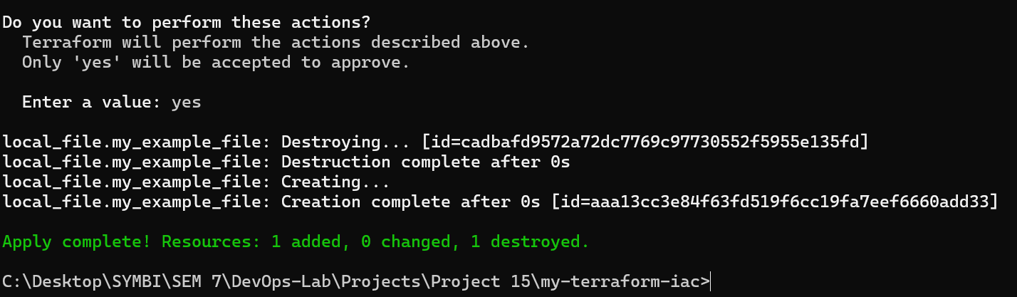  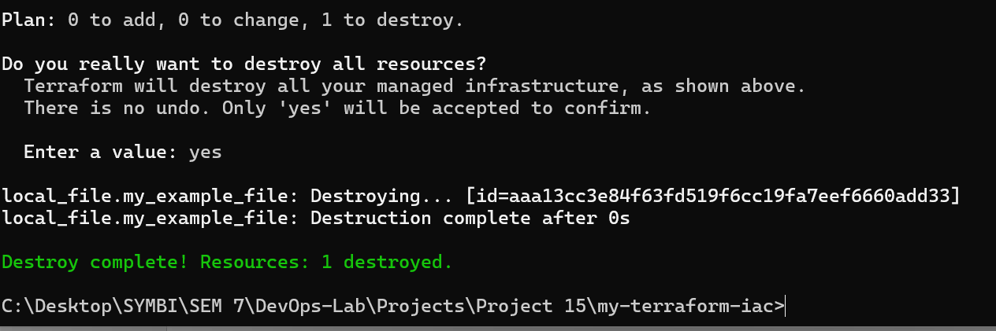  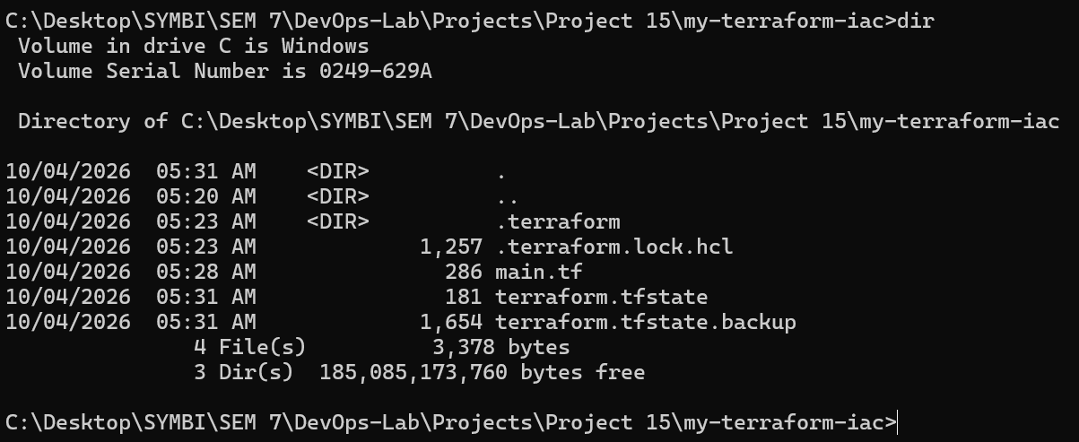

Subject Faculty Name: Prof. Arijit Dutta

